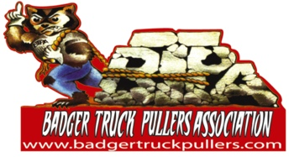
Formed in 1997, the Badger Truck Pullers Association has grown into one of the top truck pulling organizations in Wisconsin. BTPA was the first group in Wisconsin to create a sanctioned class for Super Street Diesels.
Besides the sport of pulling, BTPA also gives back to the communities by donating to various charitable organizations, offering a scholarship for youth looking to enter a trade field and supporting the Jefferson County Safe Ride Program.
Our banners are prominently displayed on the track at our pulls. Each pull that we contract has a list of our sponsors and the sponsors are mentioned as often as possible during the pull. All our members are responsible for getting schedules up in as many pubic locations as possible in their area.
To show our appreciation, sponsorship entitles you to:
- Your business name announced during our events.
- Your business name listed on our club website at www.badgertruckpullers.com
- Your business name on the schedule that gets displayed at businesses around the state.
SPONSORSHIP LEVELS
- 2ft x 6ft Banner* $300
- 2ft x 8ft Banner* $500
*Each banner sponsorship get a free ad on the schedule flyer as well as the track banner.
Sponsorship Amount $_____ Check # _____ (Copy this completed form to be used as a receipt for your tax records)
Business Name:_____________________________ Contact Name:______________________________
Address:______________________________________________________________________________
Phone:_____________________ E-mail:____________________________________________________
Business Website:______________________________________________________________________
Name of BTPA Member who collected your sponsorship:______________________ Date:____________
Make check payable to BTPA and mail with Sponsorship Form to: BTPA, W4294 Hillview Lane, Jefferson, WI 53549. Please send a copy of your logos with your form or email to badgertruckpullersWI@gmail.com
Deadline for sponsorship is May 1 so that the schedule flyer and banners can be printed for the season.
Your support is sincerely appreciated!

